**Coding challenge**

**Python**

**Name: Rohan Vinayak Chaudhari Email:**[**chaudharirohan24@gmail.com**](mailto:chaudharirohan24@gmail.com)

**Batch: Data Engineering 1**

# **Question1:** Execute Manipulating, Droping, Sorting, Aggregations, Joining, GroupeBy DataFrames

**Created Spark Session**

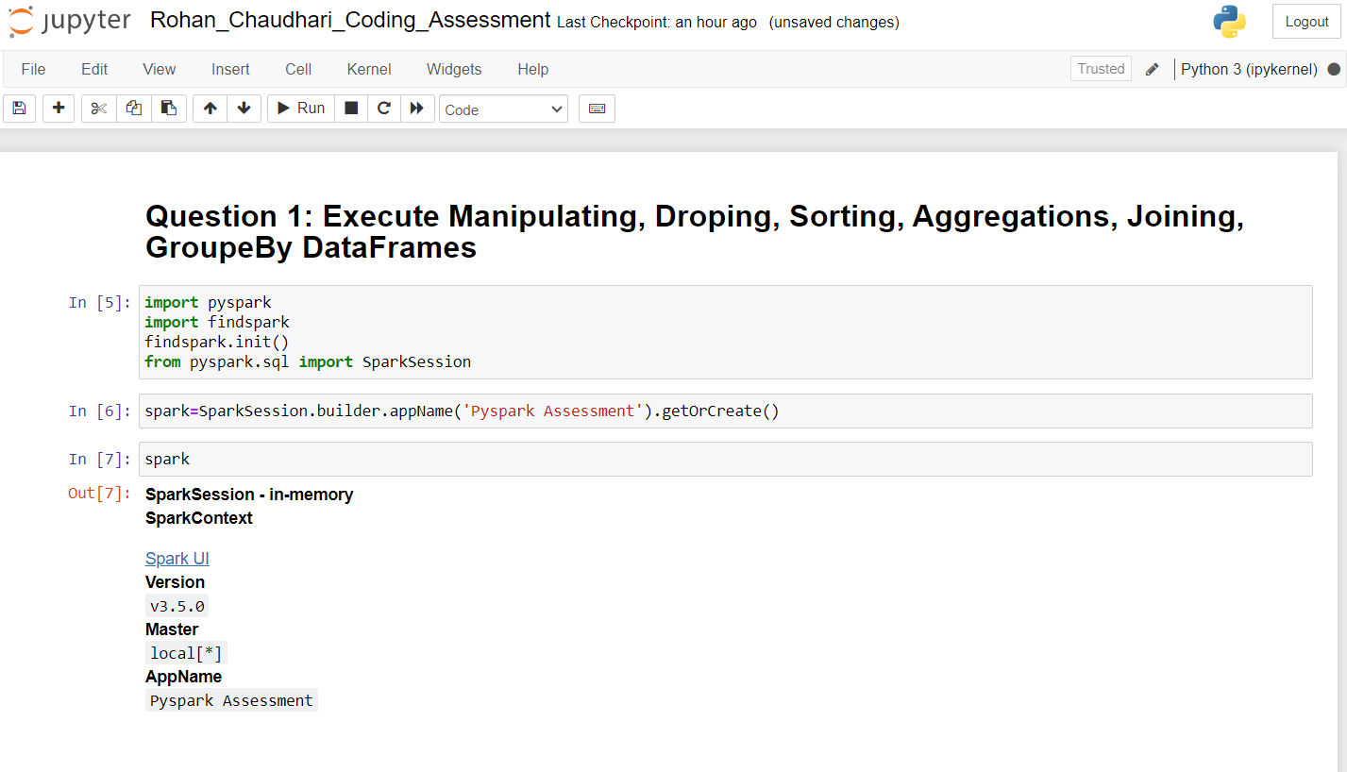

**Created DataFrame**

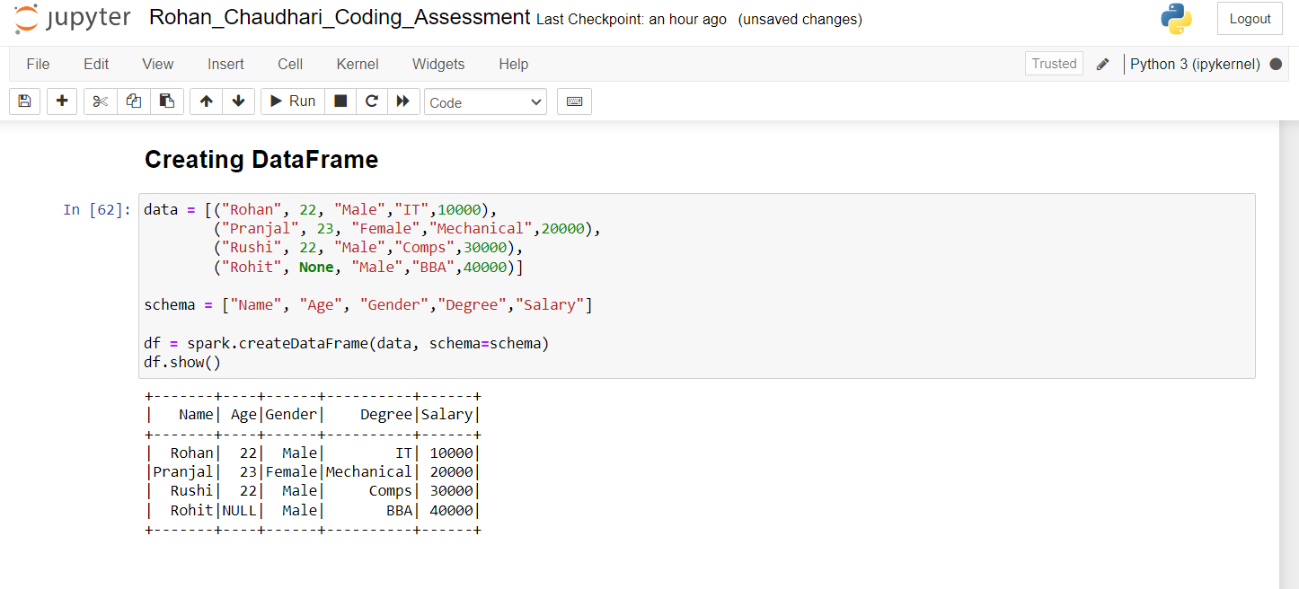

**Performed Operation as seletecting 2 columns and Filtering data based on age:**

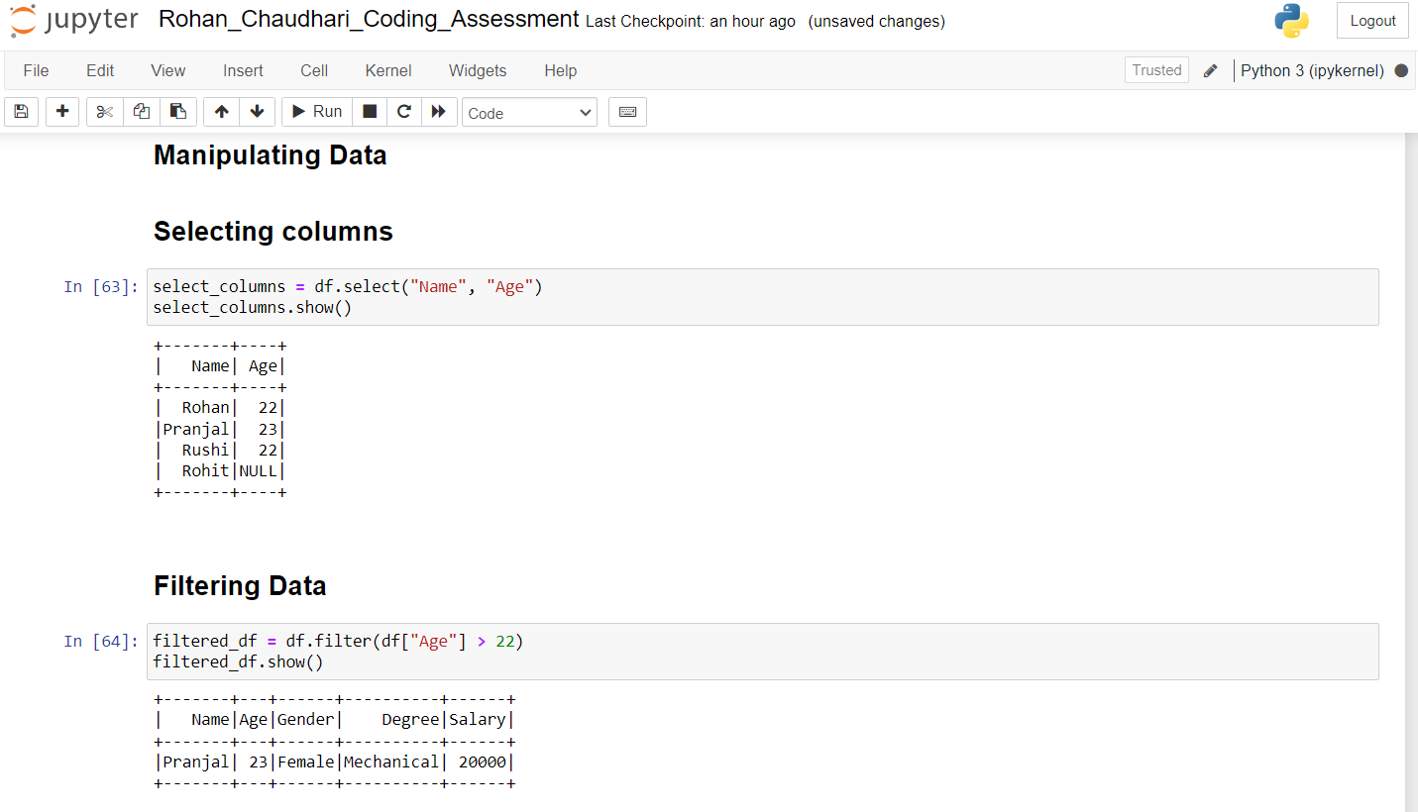

**Added a new column with 5 years ahed & Renamed the column:**

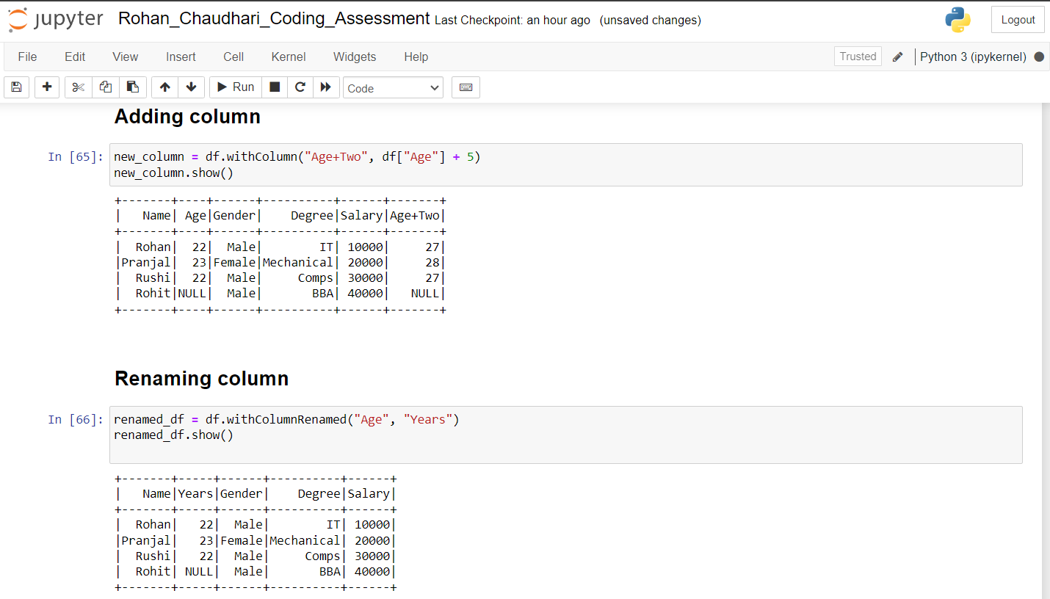

**Handled the missing value of age and filled it with 0:**

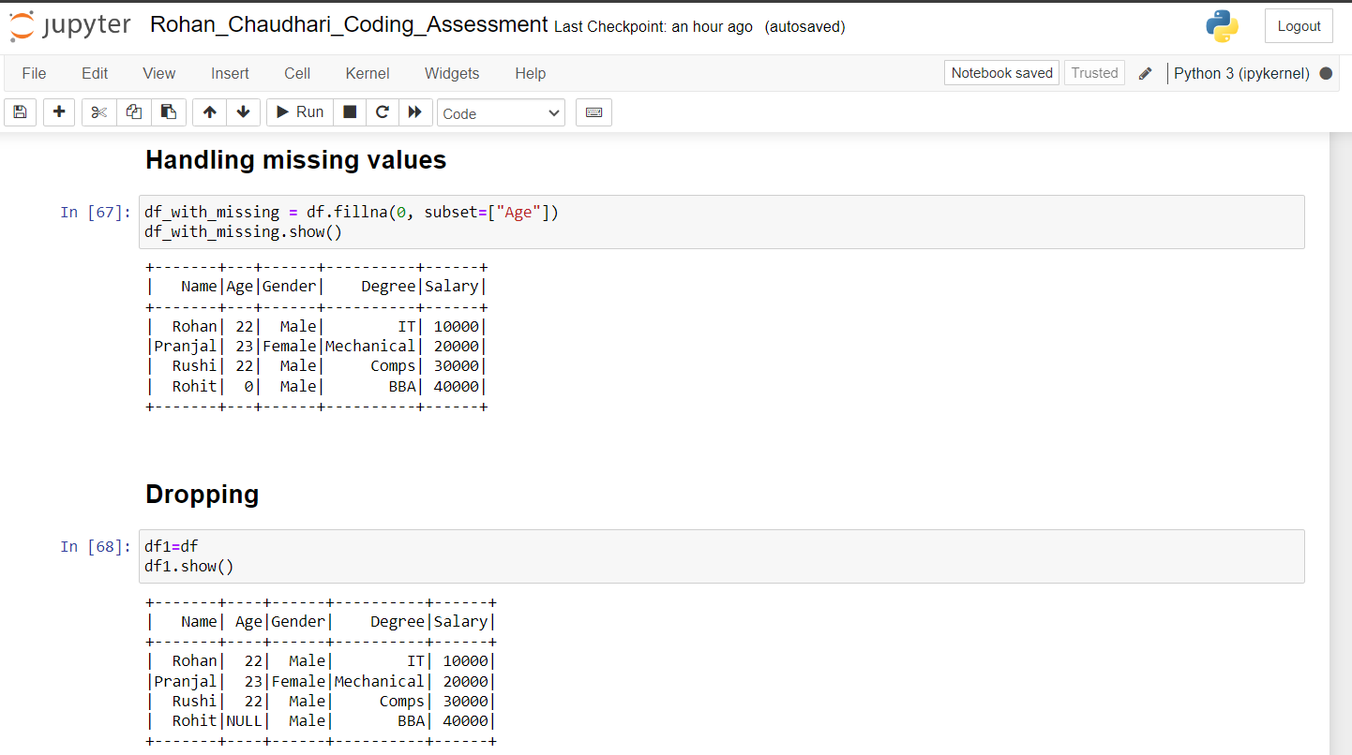

**Dropped More than 1 column & rows with missing value:**

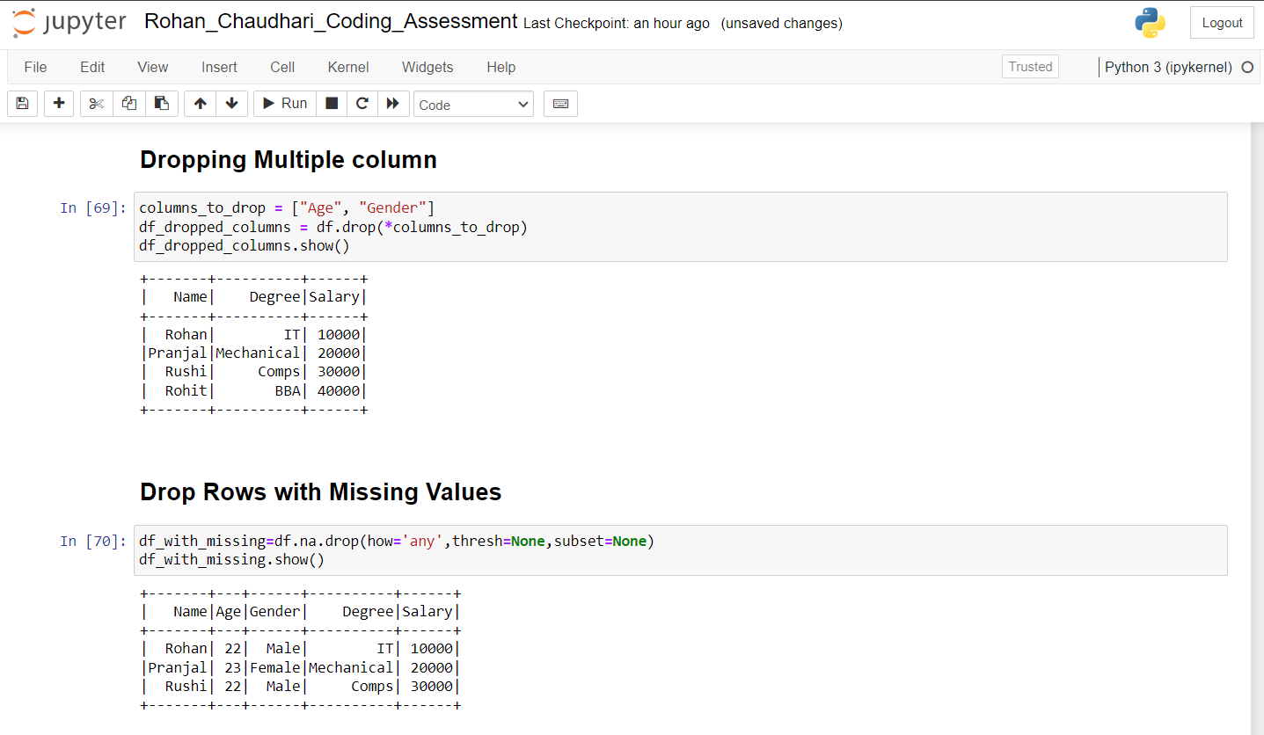

**Drop duplicate columns so for that first created duplicate rows with help of union:**

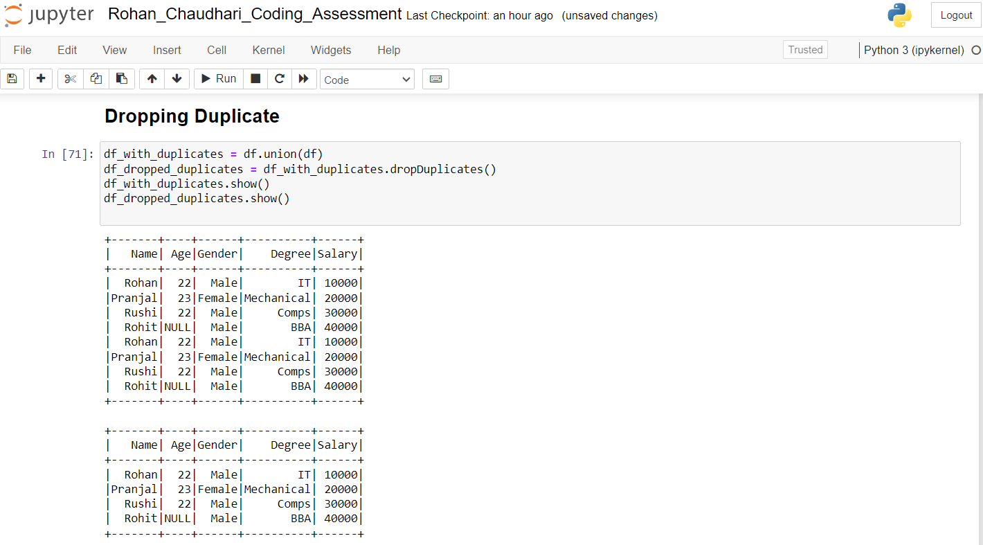

**Performed Aggregation Functions:**

**Sum,Average,Count:**

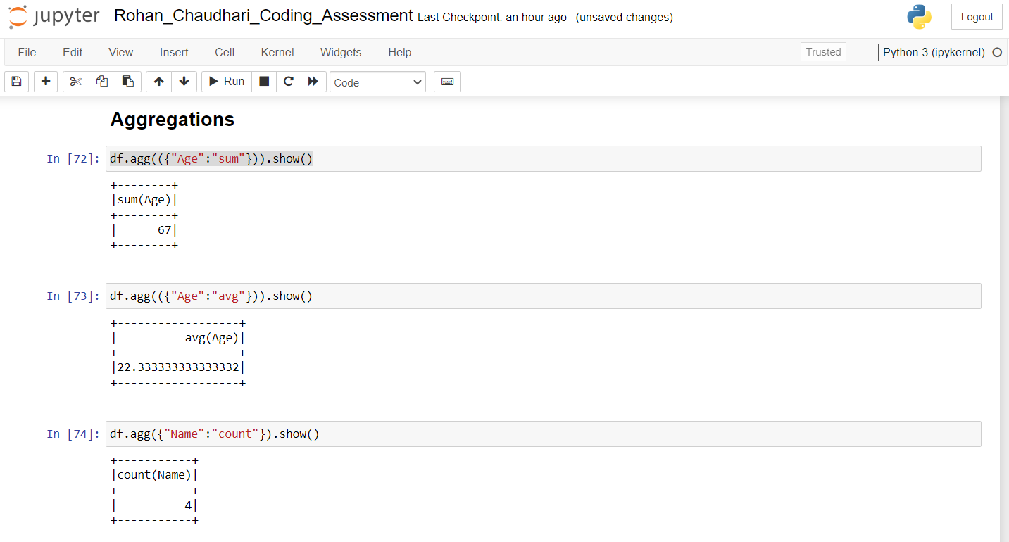

**Created another dataframe for performing joins operation here same column kept is of Name:**

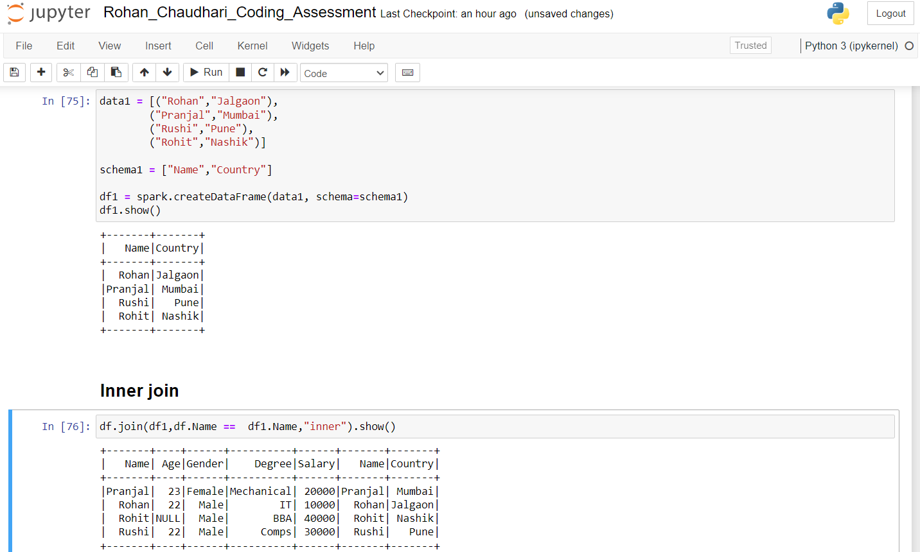

**Performed Left & Right Join operation with common column as Name:**

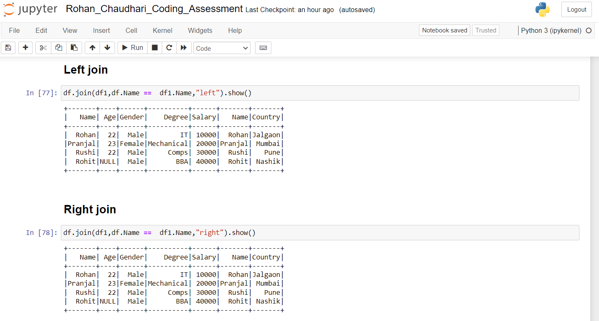

**Performed Left Semi & Anti Join operations:**

**Here Anti join output is null because every data in both table is matched:**

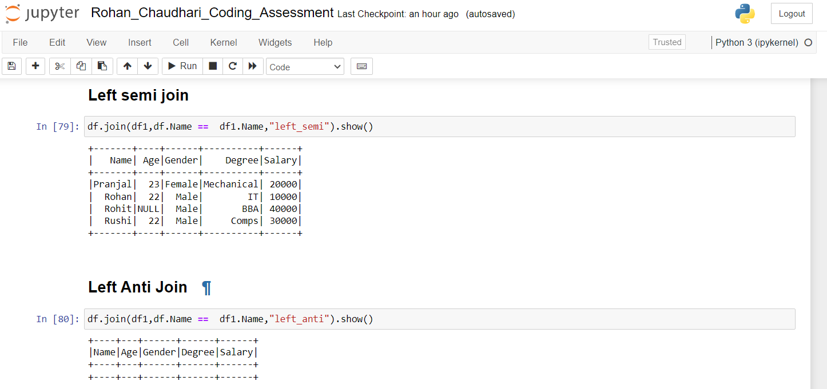

**GroupBY Operations:**

**Groupby with Sum & Min:**

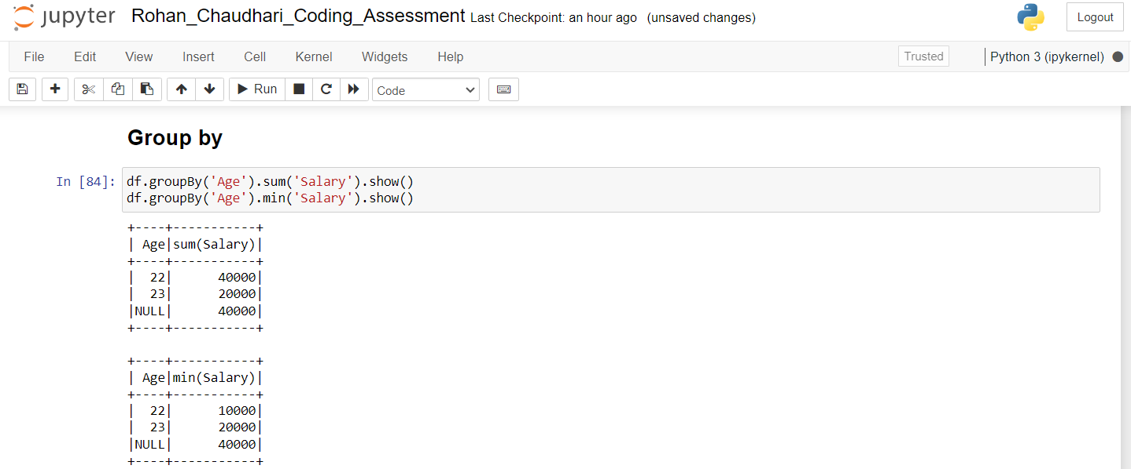

**Groupby with Max& Avg:**

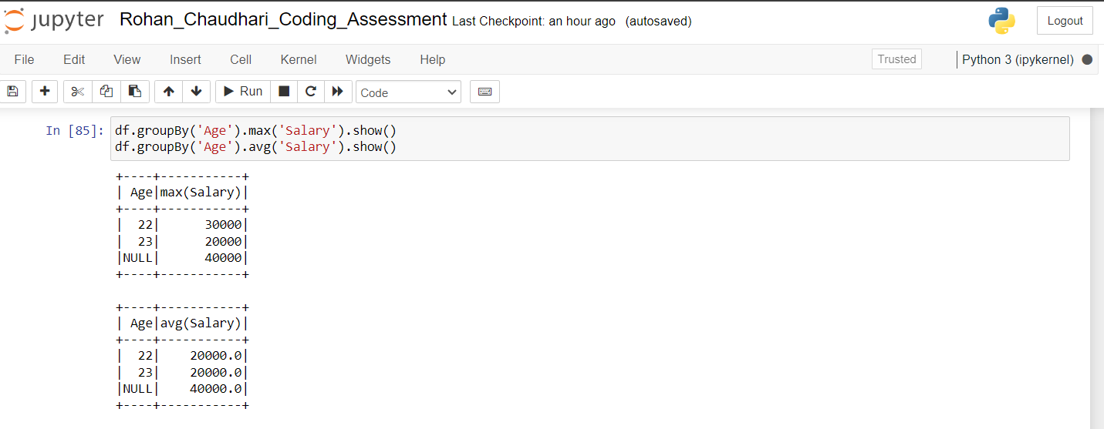

**Performed Pivot in groupBy with PIVOT kept as Gender:**

